

The company store website is <http://www.companycasuals.com/ALLIEDMACHINE>.

Please be sure to read the important information on each page.

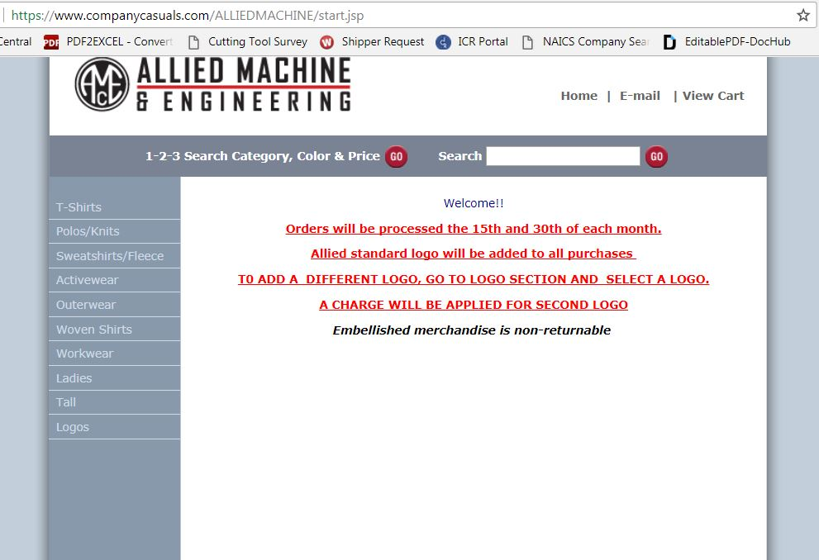

Select a category on the left side of this page and then a specific item from the middle of the page

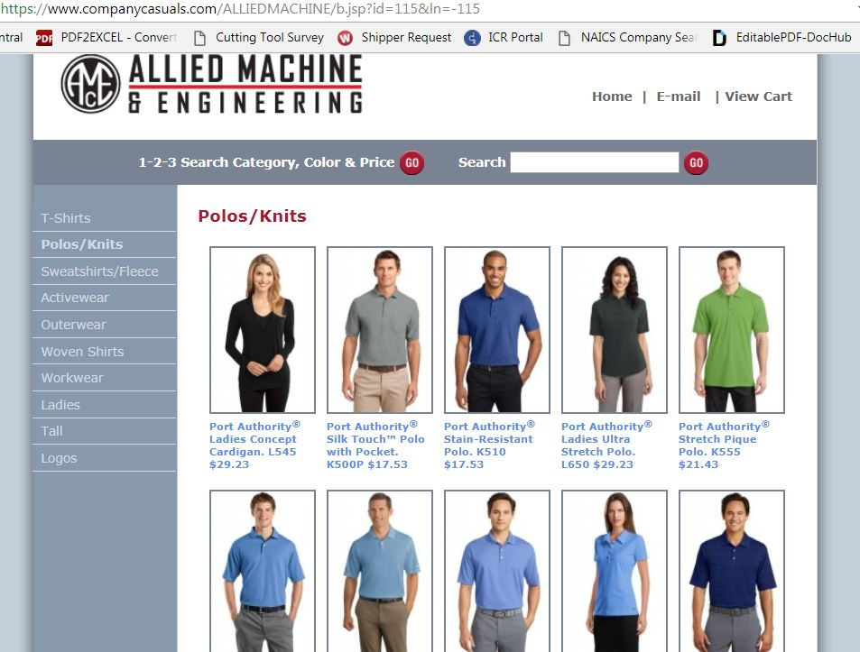

Make a color selection and click “Add decorated item to cart” in the upper right corner.

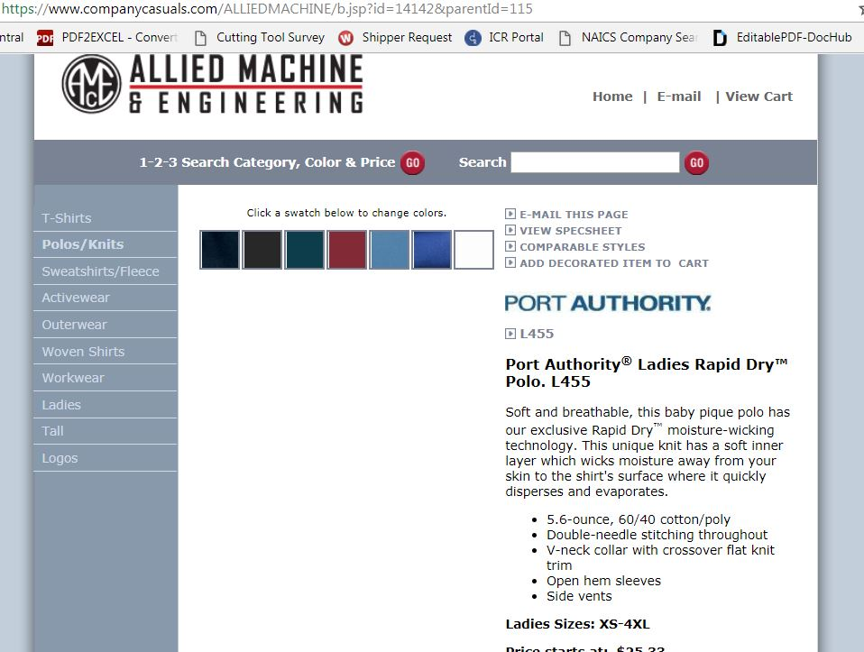

Enter the quantity desired in the color and size box and then click on update cart.

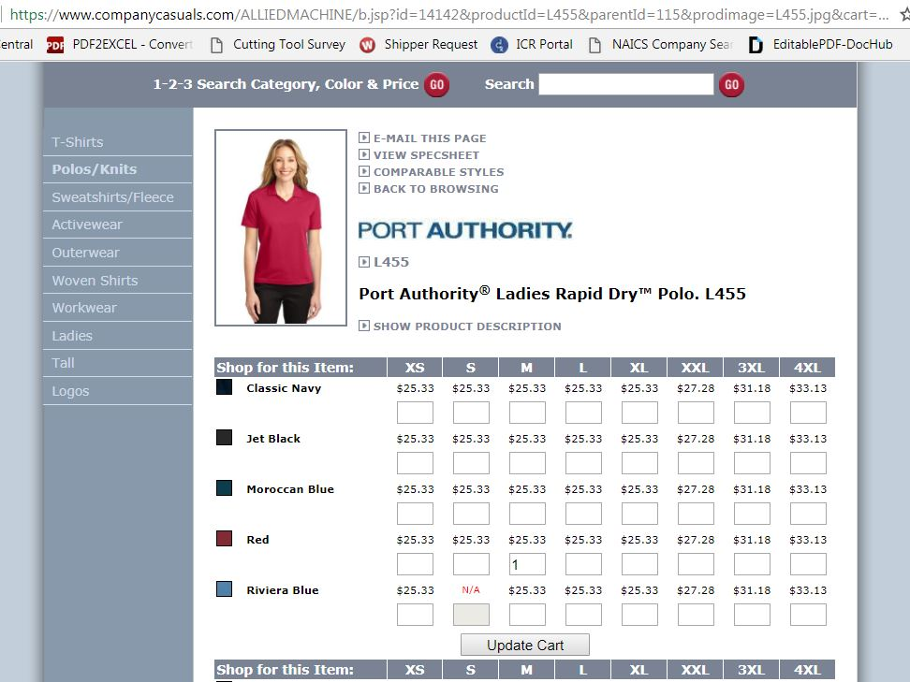

If you want the standard Allied logo, you don’t need to add a logo; however; if you want a different logo, you will need to click on Logos on the left hand side and add that logo.

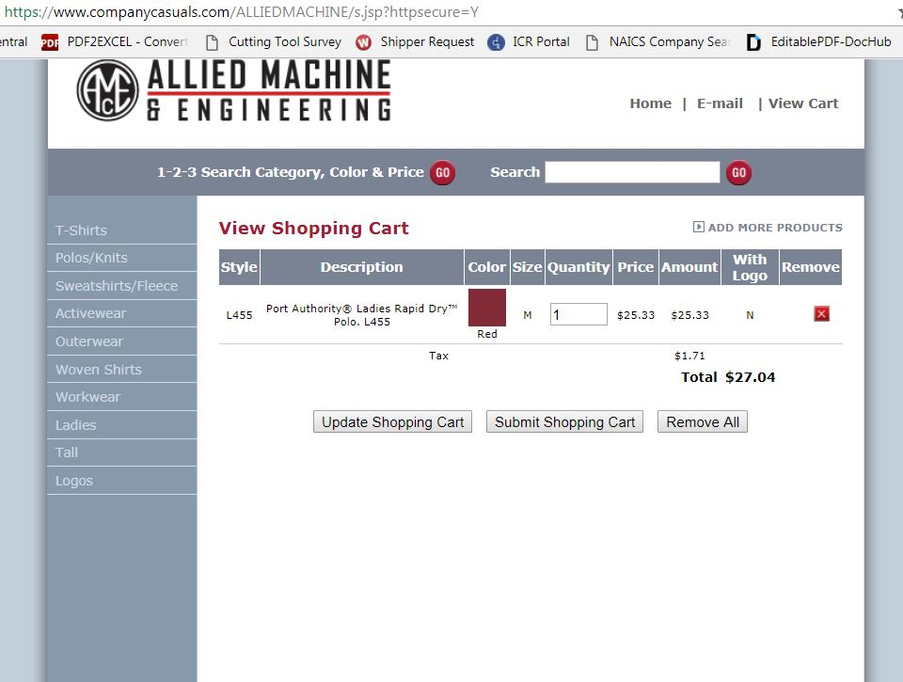

The cost of one logo per item will be covered by AMEC. If you would like the yoke logo also, you will be charged for the additional item.

Click on “Submit Shopping Cart” here to place the order.

You will need to complete the information on this page to finish the order. Please note the imprint information box. This box is required to have something in it or the order will not process. This is where you could indicate the logo color or any special instructions pertaining to the logo.

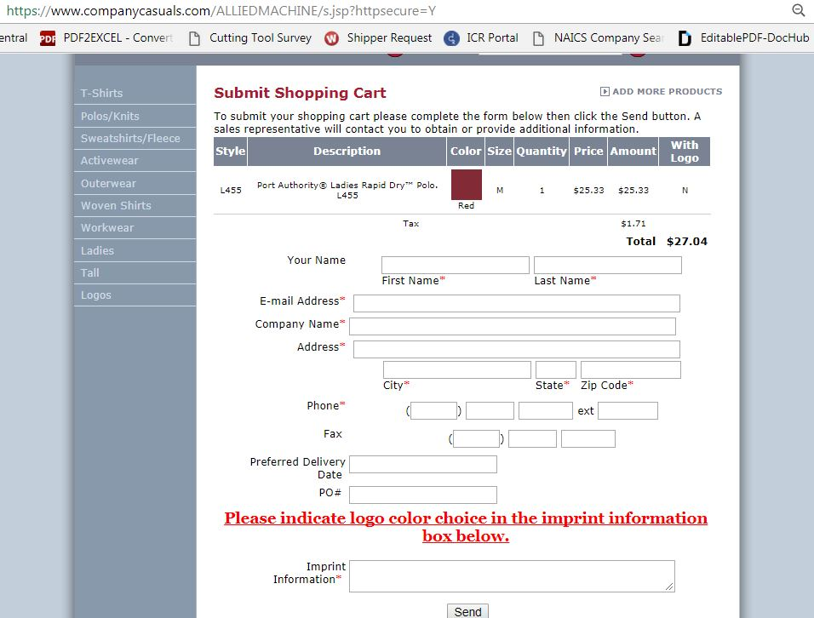

Orders will be processed on the 15th and the 30th of each month. The items should be delivered to HR about two weeks after they are processed. When the items are delivered, you will be notified that you can pick them up in HR. When you come to pick up your item, you will either need to bring a check made out to Robert’s to pay for them or sign a payroll deduction form for **ONE** pay.